Facility Administrator,
Hello! We are excited to work with you, our team, and your wonderful residents. Here is the sign-up packet. Initially we would like to offer this to all residents and see what we get back. We do have limited capacity of (INSERT HOW MANY YOU CAN TAKE ON) so we may have to limit participants based on (Insert how you want to limit, we said first come first serve)
- Please send the following pages to the decision makers for each resident however you see best.
- Then, for the first (INERT NUMBER) who return this to you, please assemble packets with the following documents for each resident:
- This Packet Completed , please make sure they fill it out appropriately and sign all the following:
  - Services Signup sheet
  - Teledent Consent
  - HIPAA Agreement
- Face Sheet (Summary of Guardianship, Diagnoses, Medications List)
- H&P: A copy of their most recent History and Physical or Wellness exam as well as any changes since this exam (any other relevant clinical notes)
- Guardianship Papers: A copy of proof of guardianship or POA
- DNR/Post orders
- Anything else you think we would need
Let me know if you need anything else from us or if you have any questions. The best way to reach me is (INSERT HOW TO GET AHOLD OF YOU) . I look forward to what this new project brings.

Thank You,
(YOUR NAME)

Residents & Families of Residents
There are many factors as people age that make this seemingly basic skill more difficult. Dry mouth, limited dexterity, vision loss, and forgetfulness are of the many factors that lead to poor compliance with recommended daily home hygiene. Even when help is offered, it is not always welcomed. Assisted Oral Hygiene/Guided Oral Hygiene is a program that puts an oral healthcare leader in the facility once per week to help the residents and caregivers be more successful completing these tasks. This is not a substitute from the regularly expected oral care, it is an upgrade. This program empowers both the residents and caregivers with knowledge, time, and a documentation system. The oral healthcare leader is typically a dental assistant, an off the clock caregiver, or a dental hygiene student. The dentist will be present to help with this leader’s initial hands-on training. This program also utilizes teledentistry for regular communication with our dentist and our hygiene team as questions or problems arise. We also offer portable professional hygiene services every 6 months. This is by no means comprehensive care. It is intended to complement care, or to at least provide basic prevention for those who struggle to get into a dental office.

(INSERT A LITTLE ABOUT YOU AND YOUR PRACTICE) .
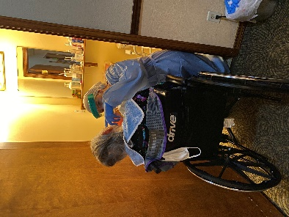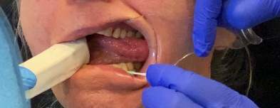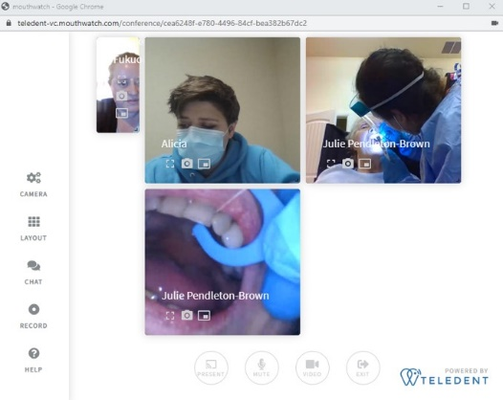
Assisted Oral Hygiene looks like this. Notice we have some special supplies to help the caregivers and oral hygiene providers have better access to see what they are doing so they can do quality work. You can also see in the picture on the right where we have a hygiene student advising a caregiver on flossing techniques using telehealth. This images was taken during the pandemic when it was necessary to lead from a distance, now and these technologies are still avialiable for screenings and consults.
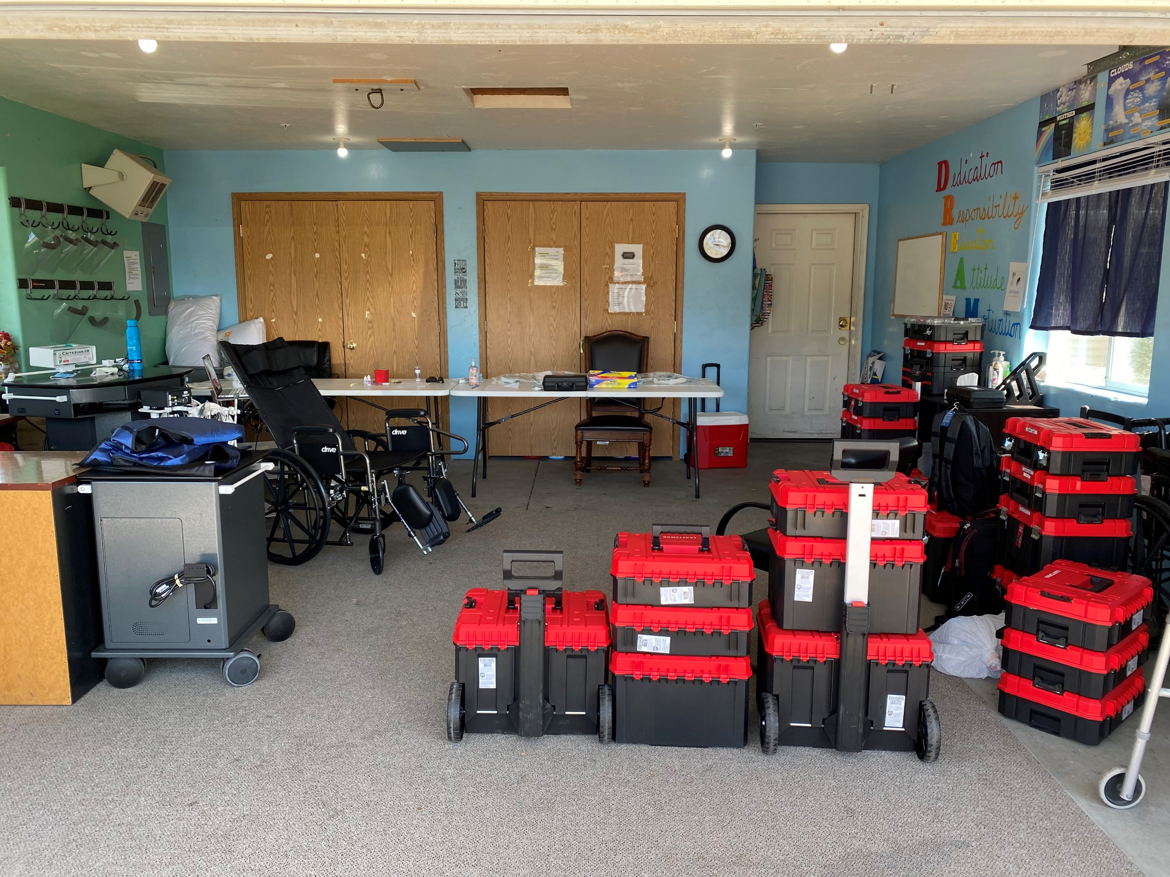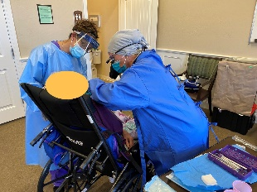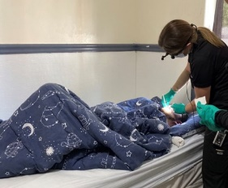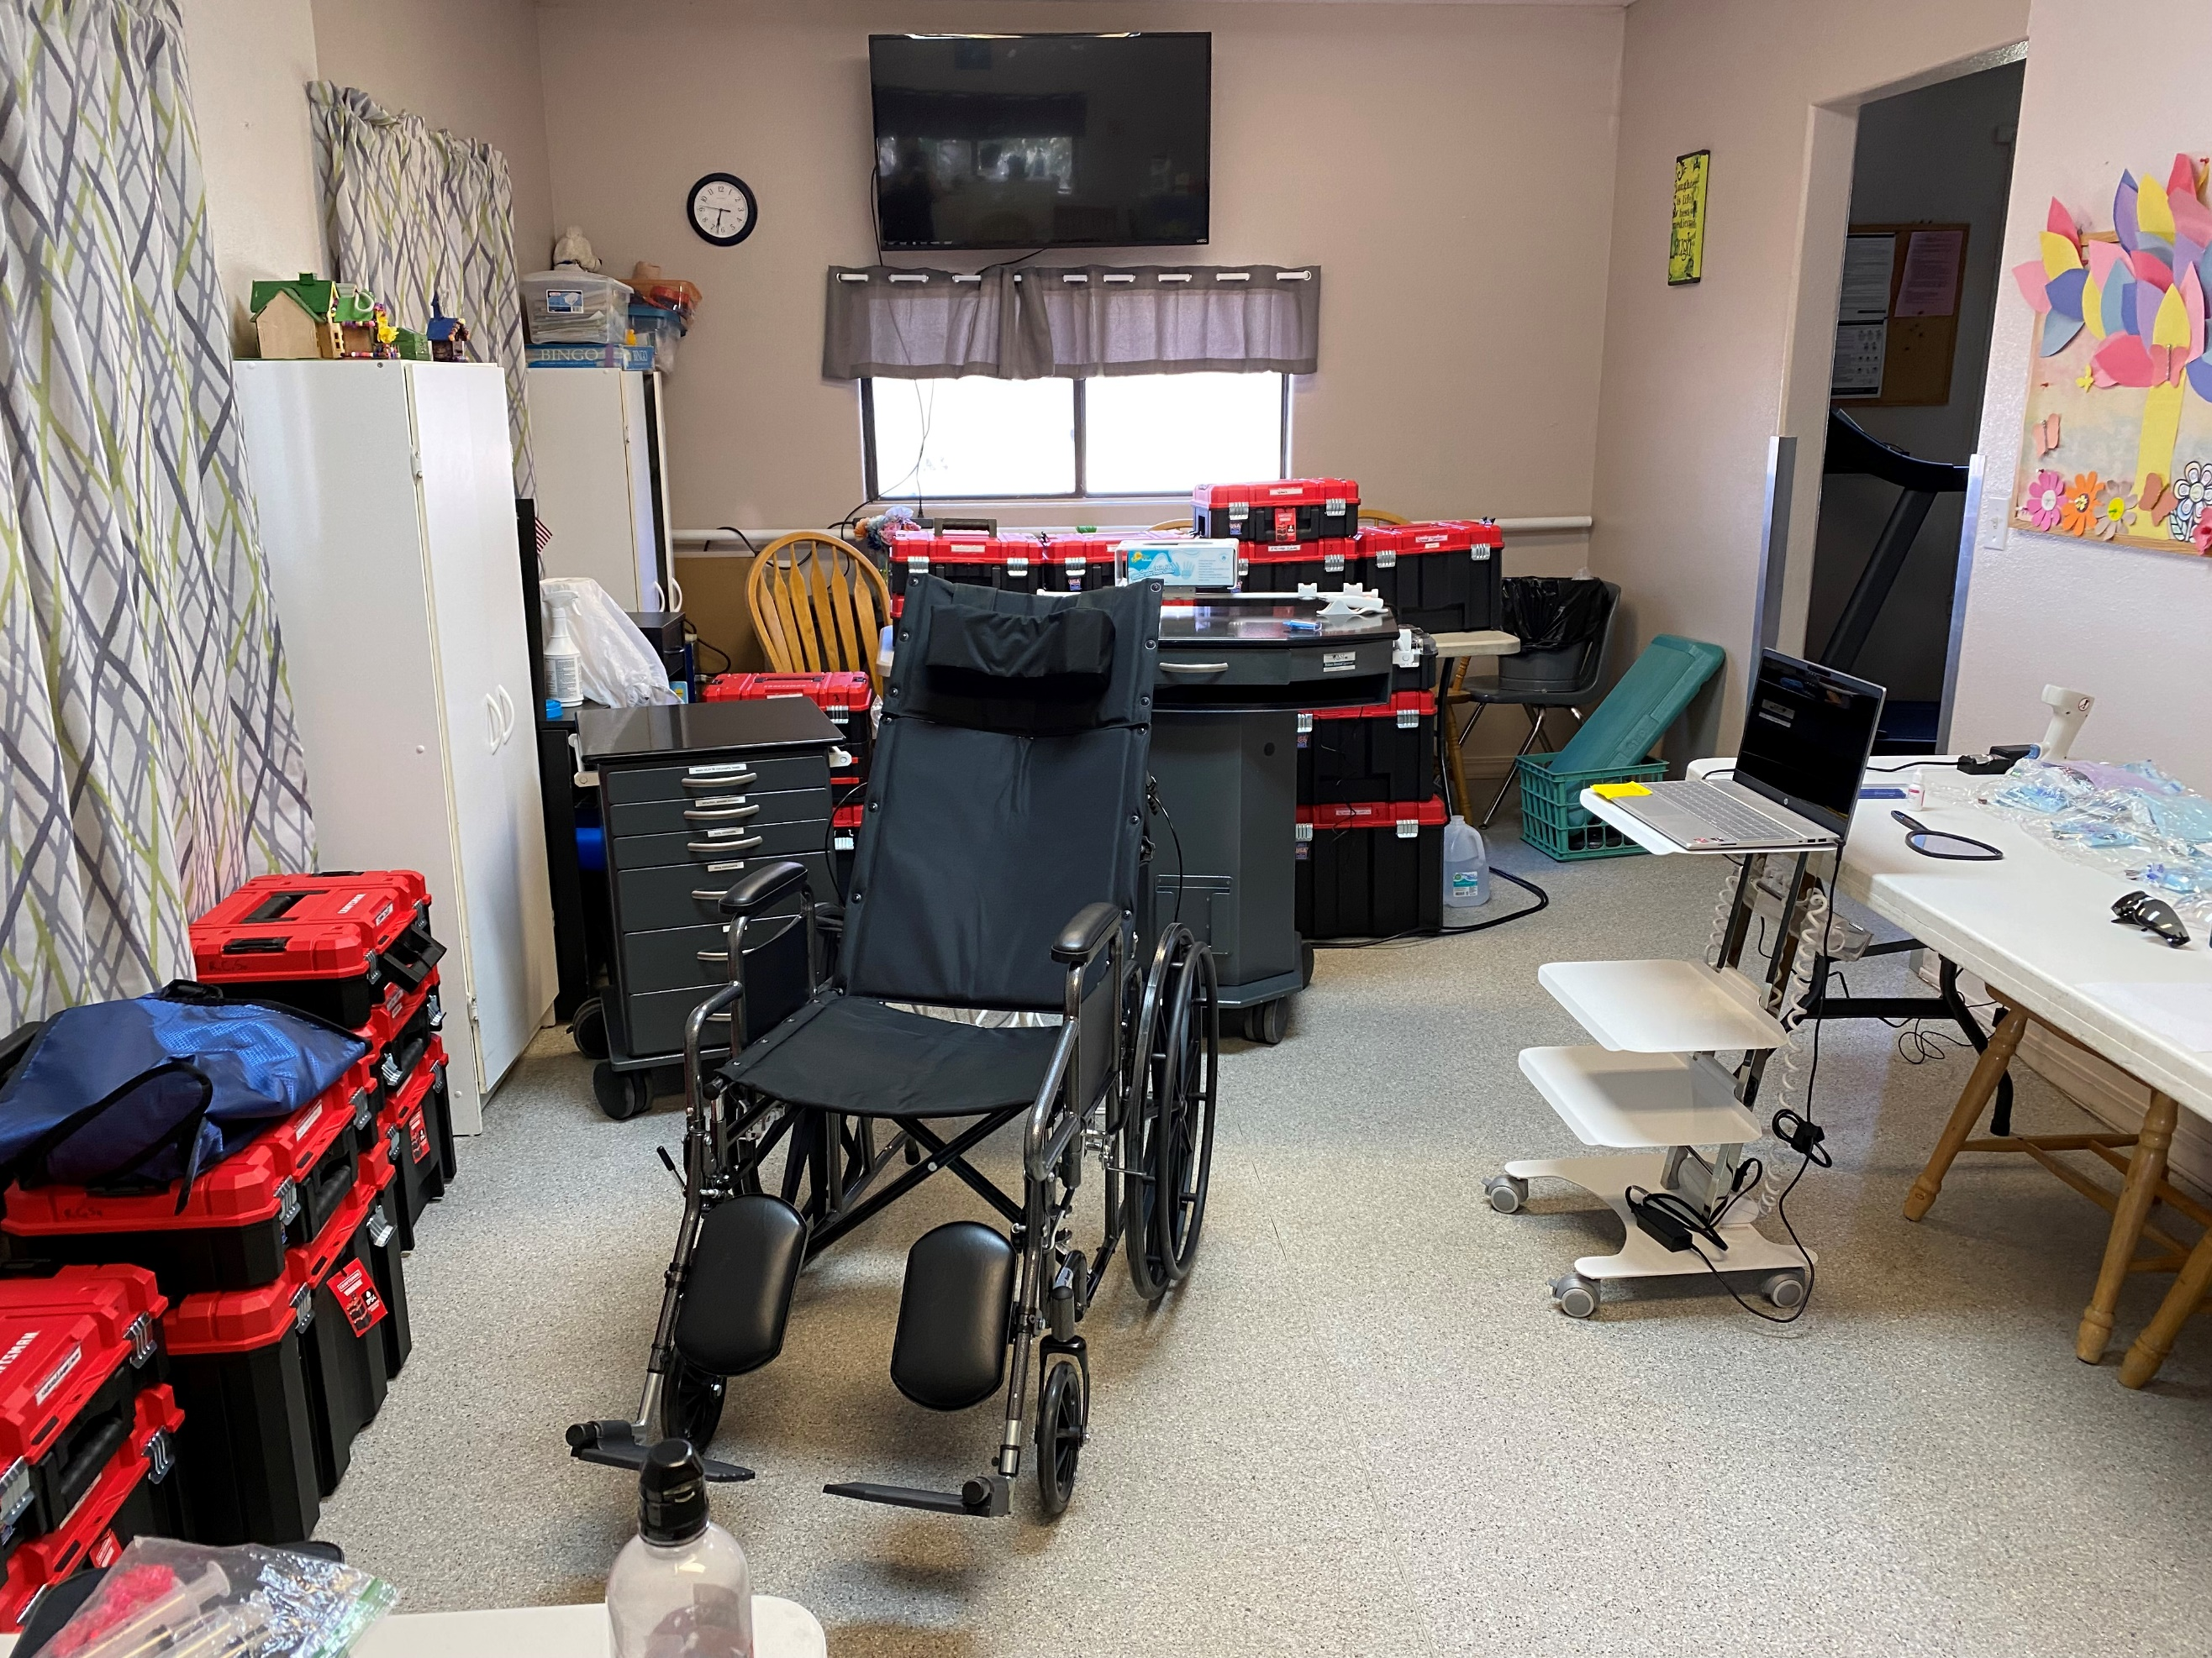
Professional Hygiene Services are delivered by a hygienist. These hygiesnists come to the home and do their best to provide a cleaning that is equal to what they could provide in a dental office. This is not the same as assisted oral hygiene which is help with brushing and flossing. This is Notice

Services Sign Up Sheets: Limited Portable Dental Services
What our program is: (INSERT YOUR PRACTICE) will be offering limited portable dental services and assistance with regular oral hygiene homecare to the residents (INSERT NAME OF FACILITY AND TOWN). Please see our “Consent for Teledental Services” for more details on what specifically we offer and do not offer. Please see our HIPAA notice of Privacy and Protection for information on how we handle private health information.
Basic Services: Please select what you are interested in:
Assisted Oral Hygiene/Guided Oral Hygiene: As people age it becomes harder to brush and floss. It is okay to need help. In our program trained hygiene students, caregivers, and assistants help residents and facility caregivers with regular oral hygiene homecare. It is our goal to have our trained team member help the resident at least once per week. This is in addition to the help they are receiving from the facility caregivers. Our trained team member will act as a leader and advocate for the resident and their oral health. They can help train family members or other caregivers upon request as well. This trained team member is not able to diagnose or give any dental advice, but can serve as a conduit to those who can. Specific homecare plans will be generated by the dentist/hygienist and the trained team member will help carry out and document these plans. We focus on keeping the resident comfortable. The resident has the right to refuse the service at any time. If a participating resident refuses, we will walk away, then return a little later and ask again. It is our goal to minimize refusal while respecting their wishes.
This service is currently supported by grant funding. We charge an initiation fee of (INSERT YOUR FEE) which comes with basic supplies. Then the resident will be billed (INSERT MONTHLY FEE IF APPLICABLE) monthly. Capacity is limited and residents will be selected (INSERT HOW YOU WILL SELECT) . As we grow our capacity, we will open to more with the goal being able to eventually offer this to all residents.
Please check one of the boxes below:
- _____Please enroll this resident in this program. If this resident is selected, I agree to pay the (INSERT FEE) initiation fee. I understand that not paying the initiation fee within a week of selection will result in the slot being offered to another resident. I also agree to pay the monthly fee each month services are delivered. I understand that I need to (INSERT HOW TO OPT OUT) to terminate this contract.
- _____Please have a team member call and talk to me more about this program.
- _____We are not interested in this portion of the program

Resident Name:_____________________________________________________ Date of Birth: ________________
Healthcare POA Name: ______________________________________Signature: ____________________________
Financial POA Name: ________________________________________Signature: ___________________________

Professional Cleanings/Screenings: We have a hygienist who will bring portable equipment out to the facility and provide professional hygiene services for two to three days approximately every 6 months. We strive to deliver services (INSERT MONTHS) and then again in (INSERT MONTHS). This will consist of x-rays when possible, a cleaning, a video/photo screening and fluoride varnish. This is a separate service from the Assisted Oral Hygiene/Guided Oral Hygiene and is billed separately. Priority will be given to those who participate in our assisted oral hygiene program / guided oral hygiene program. Hygienists will try to serve all who sign up, however there may be time limitations. This is not considered comprehensive care and we do strongly recommend you find a dental clinic that can provide comprehensive care. We are happy to work with any dental practice. If you do not have a clinic for comprehensive care, (INSERT CLINIC YOU KNOW THE RESIDENTS CAN GO TO FOR REGULAR CARE, it can be your clinic or another clinic). If you already have a dentist you work well with DO NOT LEAVE THEM. Let us know who they are and now to contact them so we can see if we can collaborate.
Please check one of the boxes below: (Adjust to third party statements applicable to your practice)
- ________ I would like to participate in these services. This resident has MCNA Idaho Medicaid Dental Coverage. I understand that the services will be covered by MCNA Idaho Medicaid Dental Coverage if this resident has not received these services in the last 6 months. If they have, I agree to pay the usual price for these services.
- ________I would like to participate in these services. This resident has Delta Dental of Idaho, I understand that I may need to pay a portion depending on this resident’s plan.
- ________I would like to participate in these services. This resident is not covered by MCNA Idaho Medicaid Dental Coverage or Delta Dental of Idaho. I understand and agree to pay the fee for these services which has been bundled into a single discounted cost of (INSERT YOUR FEE) per session. A summary of services and results of the screening will be sent with the invoice after the services are completed.
- ________I am not interested in these services currently

Regardless the services delivered, to keep it simple the fee is the same. If there are services you would rather not receive please use this line to specify what you would rather not receive: __________________________________ __________________________________________________________________________________________________________________________________________________________________________________________
* It is also important to understand that we do not help with reimbursement with any other third party payers. If you have insurance other than those mentioned above we will provide you with the notes of our services and you are welcome to seek reimbursement on your own. We apologize for any inconvenience this may cause

Resident Name:_____________________________________________________Date of Birth: ________________
Healthcare POA Name: ______________________________________Signature: ____________________________
Financial POA Name: ________________________________________Signature: ___________________________

Consent for Teledental Services
Patient Name: _________________________________________________Date :__________________
Patient Location :______________________________________________________________________
Teledentist: (INSERT NAME) ID License (INSERT LICENCE) Location: (INSERT STATE AND CITY TELEDENT)
Limited Treating Dentist: (INSERT NAME) ID License (INSERT LICENCE) Location: (INSERT LOCATION OF PRACTICE THEY CAN GET TREATMENT ).
Mobile Hygienists: (INSERT NAMES and License numbers) , If have new team members join. Their names and license numbers are available upon request.
Mobile Treatment Offered: cleanings, screenings, topical treatment of carious lesions, assisted oral hygiene, guided oral hygiene, fluoride treatments, very limited basic fillings
Treatments Not Offered: denture/partial denture fabrication/repair, crowns/bridges, implants, extractions, most fillings, dental surgery.
Comprehensive Dentistry Recommendations: We do not consider our services comprehensive dentistry nor do we provide comprehensive exams. (CHANGE THIS IF YOU DO) We do provide screenings from a dentist that are very similar to comprehensive exams so that we can ensure your safe and appropriate preventative treatments. The reason we do not consider our exams comprehensive is because we do not offer comprehensive care. We recommend patients have a comprehensive provider. We are happy to work with any dental practice that would like to work with us. If you do not already have one in mind, the (INSERT CLINIC WHERE THEY CAN GET COMP CARE)

Local Specialist if Specialty Referral Needed: There may be a time when a patient needs referral to specialty care. If that is the case either their comprehensive provider can recommend someone or we can provide a list of local specialists. We are not knowledgeable with insurance. It will be the patient’s responsibility to see if the provider is a participant in their plan.

What is Teledentistry: Teledentistry is the use of technology to perform dental examinations and to supervise treatments performed by dental team members without the dentist being physically present. Teledentistry is a convenient way to receive dental exams/screenings/treatment in the comfort of your own home. Teledentistry does have limitations and those limitations may vary patient to patient. The dentist will determine if an exam or treatment can be performed utilizing teledentistry.
Information Security Measures: As with all information transmitted there is risk of security breach. To decrease this risk as much as possible, all our computers are encrypted using Windows 10 Pro encryption. Your data will be stored on a HIPPA compliant, encrypted cloud-based software program. We utilize Mouthwatch Teledent and Mail HIPPO. All employees of (INSERT YOUR PRACTICE) are trained annually in HIPPA compliance through pre-recorded videos. (ADJUST THIS PARAGRAPH TO WHAT YOU USE)
Potential Loss of Data: As with all technology there is a small chance information can be lost. If information is lost before the dentist can properly examine it, we will return and recollect the information at no charge.
Our Teledental Protocols:
- Demographic information as well as medical history will be obtained from the facility’s administrators and/or patient/guardian. Dentist will review all of this prior to any treatment.
- Dentist will establish relationship with the patient either in person or through a synchronous video interaction
- A member of our team will gather photo and video data for our initial review.
- Hygienist will then come to provide cleaning, x-rays, fluoride, oral hygiene plan, and take photos/videos.
- Dentist will review the photos, videos and x-rays at a remote site and then will contact the patient or guardian to present her/his findings and answer any questions. Referral to an outside practice may be made or the dentist may come perform simple treatments. This is not a comprehensive exam but rather a screening that is done by the dentist.
- Once oral health is established, it is important to maintain it. Regular professional cleanings and fluoride application are very important in prevention. It is our goal to have our hygienists return every 6 months to provide preventative recare services for all patients.
- Periodic screenings will be performed via teledentistry.
- For those residents who are participating in our Assisted Oral Hygiene/Guided Oral Hygiene program, videos will be taken and reviewed more frequently. These will be reviewed by one of our trained hygienists and also by the dentist if the hygienist sees something of concern. It is our goal for these participants to receive help with basic oral hygiene at least once per week from someone on our team.
What if the patient already has a dentist? If a patient has a dentist, and they are still able to see that dentist regularly, we do not recommend changing. We value long lasting dental relationships and we want patients to stay with their dental home as long as they can. However, when the time comes that the patient can no longer regularly see their dentist, we are here. We are also happy to work with your dentist to establish a care plan where we both play a role. To make sure the patient receives continuous care. Comprehensive care is the best. We are not comprehensive care.
Please Sign Below:
I am the patient below or the legal guardian for the patient below and am authorized to make this decision on behalf of the below listed patient. I choose to have the below listed patient participate in the Your Special Smiles teledental program.
Patient Name Printed: ___________________________________Patient Birthday: __________________________
Signature: ______________________________________________________Date:__________________________
Printed name if different than patient: ______________________________________________________________

HIPAA Your Information. Your Rights. Our Responsibilities.
This notice describes how medical information about you may be used and disclosed and how you can get access to this information. Please review it carefully

Your Rights
When it comes to your health information, you have certain rights. This section explains your rights and some of our responsibilities to help you. You have the right to:
Get an electronic or paper copy of your medical record
- You can ask to see or get an electronic or paper copy of your medical record and other health information we have about you. Ask us how to do this.
- We will provide a copy or a summary of your health information, usually within 30 days of your request. For paper charts over 5 pages we will charge $0.10 per page. For digital charts we will charge the cost of the device we use to transfer the files.
- You can also request your record be emailed to you. We will send this encrypted, however there are still risks with interception of this email. If you select this method you are assuming the risk of a cyber breach of your information. This is at no cost.
Ask us to correct your medical record
- You can ask us to correct health information about you that you think is incorrect or incomplete.
- We may deny the request for change, but we’ll tell you why in writing within 60 days and we will add your request to your chart to reflect your disagreement with our records.
Request confidential communications
- You can ask us to contact you in a specific way (for example, home or office phone) or to send mail to a different address. We will comply with reasonable requests.
Ask us to limit what we use or share
- You can ask us not to use or share certain health information for treatment, payment, or our operations. We are not required to agree to your request if it would affect your care.
- If you pay for a service or health care item out-of-pocket in full, you can ask us not to share that information for the purpose of payment or our operations with your health insurer. We will comply unless a law requires us to share that information.
Get a list of those with whom we’ve shared information
- You can ask for a list (accounting) of the times we have shared your health information for six years prior to the date you ask, who we shared it with, and why.
- We’ll provide one accounting a year for charge a cost-based fee.
Get a copy of this privacy notice
- You can ask for a paper copy of this notice at any time, even if you have agreed to receive the notice electronically. We will provide you with a paper copy promptly. To conserve resources, our default is electronic for hospital cases.
Choose someone to act for you
- If you have given someone medical power of attorney or if someone is your legal guardian, that person can exercise your rights and make choices about your health information.
- We will make sure the person has this authority and can act for you before we take any action.
File a complaint if you feel your rights are violated
- You can complain if you feel we have violated your rights by contacting us directly. We prefer this method so we can address the problem rapidly and make sure that the problem is solved for others.
- You can file a complaint with the U.S. Department of Health and Human Services Office for Civil Rights by sending a letter to 200 Independence Avenue, S.W., Washington, D.C. 20201, calling 1-877-696-6775, or visiting www.hhs.gov/ocr/privacy/hipaa/complaints/.
- We will not retaliate against you for filing a complaint.

Your Choices
For certain health information, you can tell us your choices about what we share. If you have a clear preference for how we share your information in the situations described below, talk to us. Tell us what you want us to do, and we will follow your instructions.
In these cases, you have both the right and choice to tell us to:
- Share information with your family, close friends, or others involved in your care
- Share information in a disaster relief situation
If you are not able to tell us your preference, for example if you are unconscious, we may go ahead and share your information if we believe it is in your best interest. We may also share your information when needed to lessen a serious and imminent threat to health or safety.
You have the right to not sign our photo/information release form. Our Photo/Information release form gives us permission to share your information for:
- Marketing/Fundraising purposes
- Political/regulative/ legislative
- Educational Purposes
- Any Other Purpose

Our Uses and Disclosures

How do we typically use or share your health information?
Treat you
We can use your health information and share it with other professionals who are treating you.
Example: A doctor treating you for an injury asks another doctor about your overall health condition.
Run our organization
We can use and share your health information to run our practice, improve your care, and contact you when necessary.
Example: We use health information about you to manage your treatment and services.
Bill for your services
We can use and share your health information to bill and get payment from health plans or other entities. We also use your information to meet the needs of our grant funding. With grant funding, your name will not be attached.
Example: We give information about you to your health insurance plan so it will pay for your services.

How else can we use or share your health information?
We are allowed or required to share your information in other ways – usually in ways that contribute to the public good, such as public health and research. We have to meet many conditions in the law before we can share your information for these purposes. For more information see: www.hhs.gov/ocr/privacy/hipaa/understanding/consumers/index.html.
Help with public health and safety issues
We can share health information about you for certain situations such as:
- Preventing disease
- Helping with product recalls
- Reporting adverse reactions to medications
- Reporting suspected abuse, neglect, or domestic violence
- Preventing or reducing a serious threat to anyone’s health or safety
Do research
We can use or share your information for health research.
Comply with the law
We will share information about you if state or federal laws require it, including with the Department of Health and Human Services if it wants to see that we’re complying with federal privacy law.
Respond to organ and tissue donation requests
We can share health information about you with organ procurement organizations.
Work with a medical examiner or funeral director
We can share health information with a coroner, medical examiner, or funeral director when an individual dies.
Address workers’ compensation, law enforcement, and other government requests
We can use or share health information about you:
- For workers’ compensation claims
- For law enforcement purposes or with a law enforcement official
- With health oversight agencies for activities authorized by law
- For special government functions such as military, national security, and presidential protective services
Respond to lawsuits and legal actions
We can share health information about you in response to a court or administrative order, or in response to a subpoena.

Our Responsibilities
- We are required by law to maintain the privacy and security of your protected health information.
- We will let you know promptly if a breach occurs that may have compromised the privacy or security of your information.
- We must follow the duties and privacy practices described in this notice and give you a copy of it.
- We will not use or share your information other than as described here unless you tell us we can in writing by consenting to our photo release form. If you tell us we can, you may change your mind at any time. Let us know in writing if you change your mind.
For more information see: www.hhs.gov/ocr/privacy/hipaa/understanding/consumers/noticepp.html.

Changes to the Terms of this Notice

We can change the terms of this notice, and the changes will apply to all information we have about you. The new notice will be available upon request, in our office, and on our web site.

Other Instructions for Notice
- This notice is effective starting September 1, 2018 and will be reviewed every three years unless other changes dictate the need for sooner review.
- Our HIPPA privacy officer is (INSERT OFFICER NAME AND CONTACT)
- We are very active advocates for adults who have special needs and geriatric patients with limited mobility. We appreciate your willingness to share your information to help others obtain access to care. If you choose not to sign our photo/information release form we will understand and treat you just the same. We understand there are very valid reasons some people do not want their information or photos to be viewed publicly. Due to the difficulty of separating those who have consent and those who do not have consent, we will not take any photos of patients who do not have consent that contain any patient identifiers.
- We operate in partnership with multiple other entities. These entities are responsible for their own patient HIPPA compliance. If you live in a group home, assisted living facility, skilled nursing facility, or any other facility that coordinates your treatment, a summary of your visit will be sent to that entity unless you or your guardian requests it not to be. After giving them the summary, they assume responsibility to maintain your privacy of that document. We also partner with St. Luke’s. If procedures are performed at the hospital, we will enter a summary in their electronic health record system. If you are a patient of another dental practice your records will be sent to them unless you request them not to be. They will be responsible for the maintenance of that record and the compliance.

I have been given a chance to read the Notice of Privacy Practice and was given the opportunity to ask any questions.
Print patients name: _____________________________________Date: _________________________
Signature of Patient or Patient’s legal representative: _________________________________________
Print name of legal representative (if applicable) :____________________________________________

